**DAILY ONLINE ACTIVITIES SUMMARY**

|  |  |  |  |  |  |
| --- | --- | --- | --- | --- | --- |
| **Date:** | **26-05-2020** | | **Name:** | **Shanbhag Atish Manoj** | |
| **Sem & Sec** | **6th - B** | | **USN:** | **4AL17CS085** | |
| **Online Test Summary** | | | | | |
| **Subject** | **CGV** | | | | |
| **Max. Marks** | **30** | **Score** | | **20** | |
| **Certification Course Summary** | | | | | |
| **Course** | **Full stack web development** | | | | |
| **Certificate Provider** | **Udemy** | **Duration** | | | **19.5 hours** |
| **Coding Challenges** | | | | | |
|  | | | | | |
| **Status: executed** | | | | | |
| **Uploaded the report in GitHub** | | **Yes** | | | |
| **If yes Repository name** | | <https://github.com/atish-shanbhag/Updates> | | | |
| **Uploaded the report in slack** | | **Yes** | | | |

Online Test Details:

Second I A of CGV

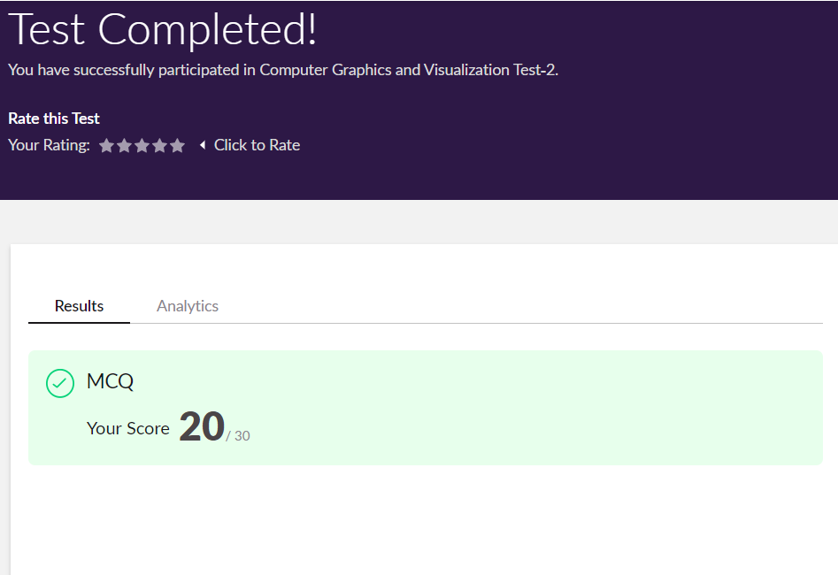

Certification Course Details:

Report

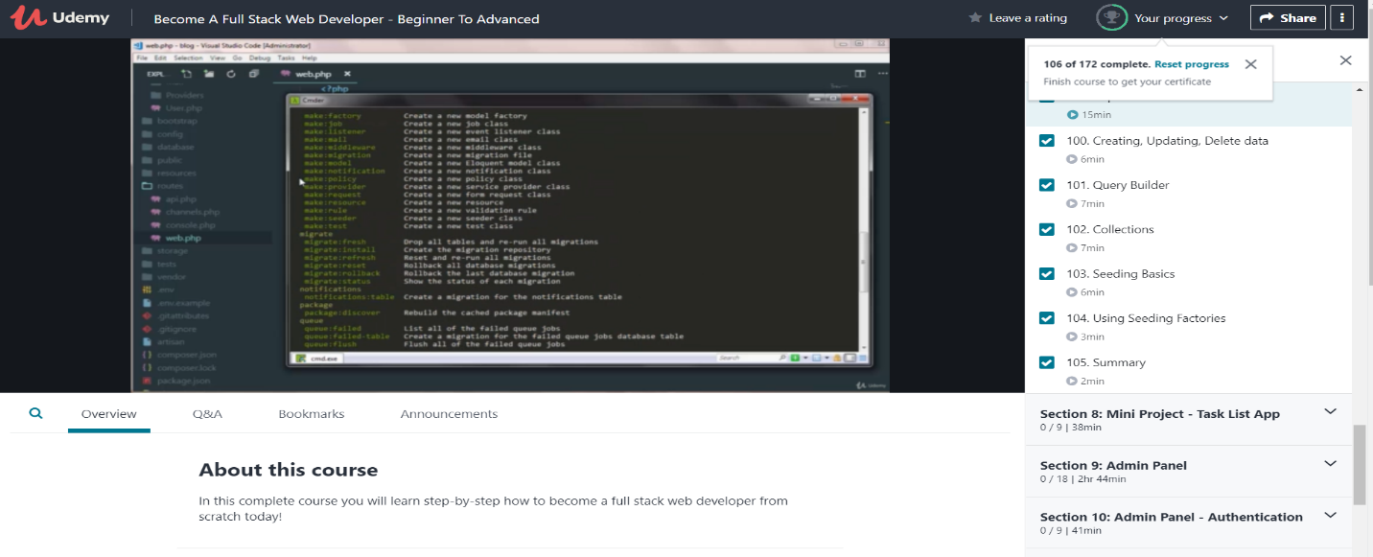

In todays session for online certification I have studied about Laravel script and its various states and its working too.

Coding Challenges Details:

The below GitHub link for details

<https://github.com/atish-shanbhag/Updates>

P-1

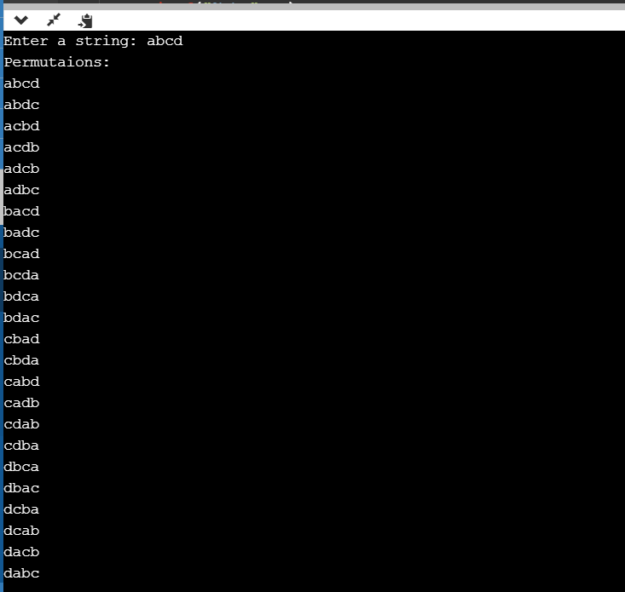

P-2

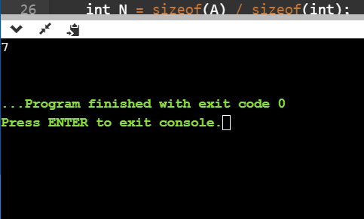

**P-3**

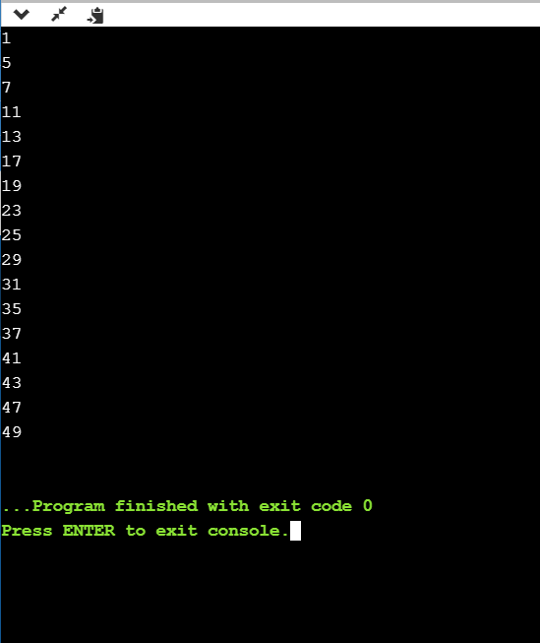

**P-4.1.1 & 4.1.2**

